**The input Demosalesmanager has been entered sucessfully**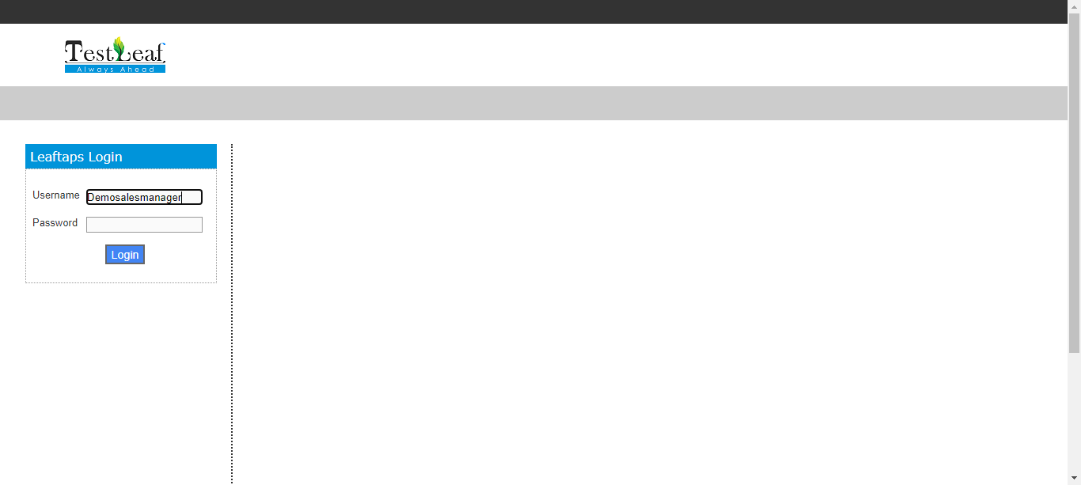

**The input crmsfa has been entered sucessfully**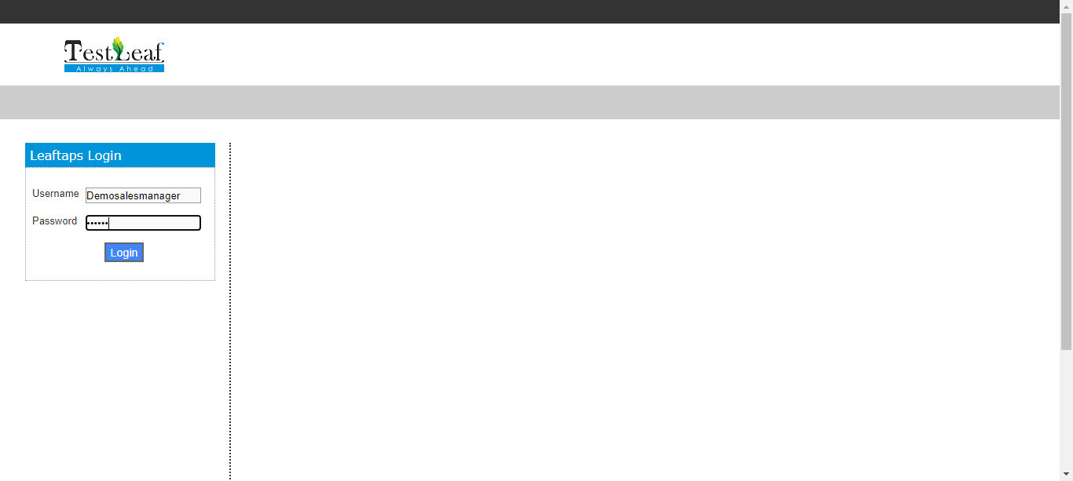

**The Element is clicked**